## 5.Our discussion with the AHUT Industrial Robotics Competition team

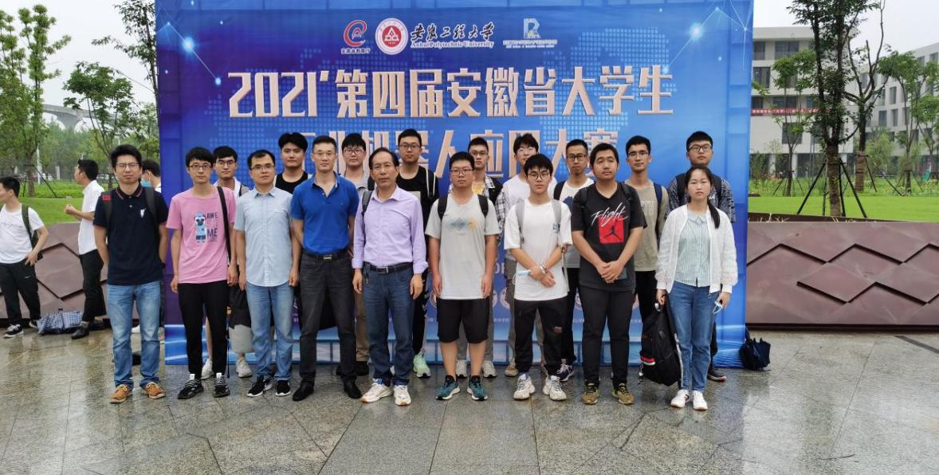

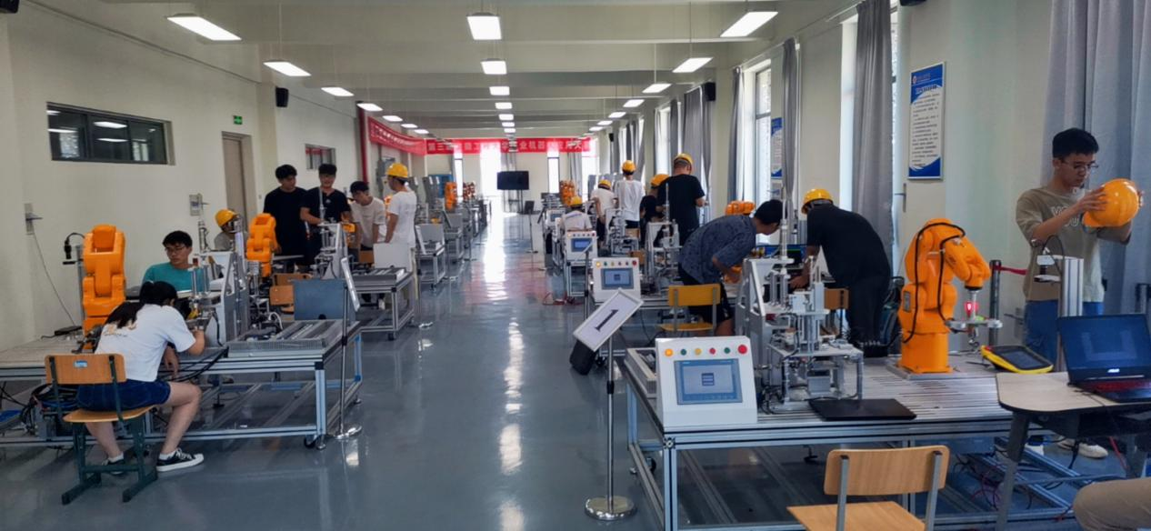

We discuss the guiding significance of industrial robots to automatic assembly line production to speed up the drug R & D cycle.

**6.Field investigation in the oncology department of Ma'anshan People's Hospital**

The team members went to the Oncology Department of Ma'anshan People's Hospital for field investigation

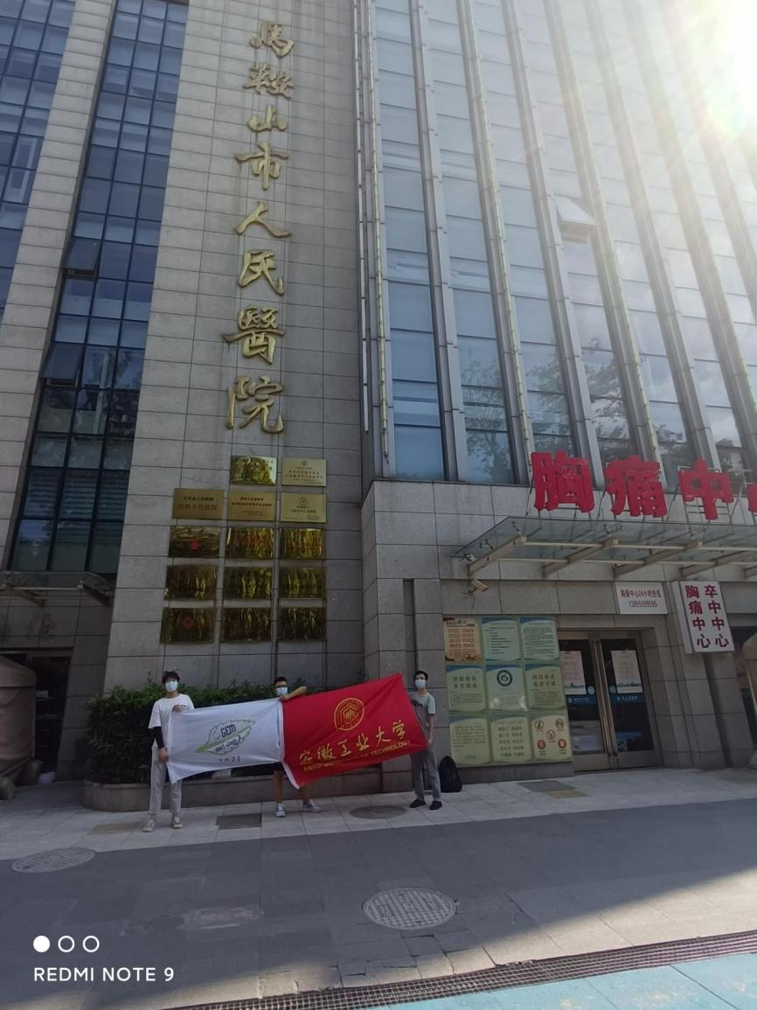

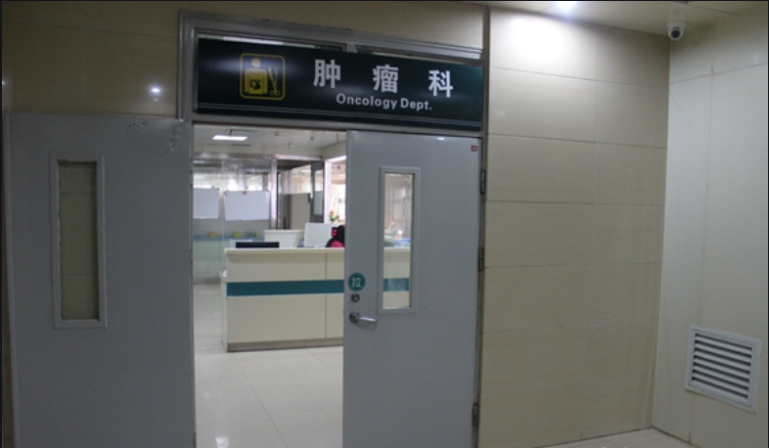

In order to understand the specific treatment process and treatment drugs for malignant tumors, our team contacted the oncology staff of Ma'anshan People's Hospital in August. On the premise of personal protection and not interrupting the regular treatment of the medical staff, we witnessed how they work with tumors.

A malignant tumor is one of the primary diseases that harm human health. The treatment of tumors is the comprehensive application of surgery, radiotherapy, chemotherapy, interventional therapy, and traditional Chinese Medicine Treatment therapy.At present, the most commonly used biological treatment in clinical practice is trastuzumab injection. For breast cancer patients whose chemotherapy is ineffective, this method can achieve a certain therapeutic effect. Breast cancer patients can also consider using traditional Chinese medicine for treatment, but this method needs to be combined with other methods such as surgery to achieve the purpose of strengthening the body and eliminating evil. Through traditional Chinese medicine treatment, it can effectively enhance the body's anti-cancer ability and reduce the side effects of other treatments.

Meanwhile, we understand that all current traditional cancer therapies have large side effects, and it will attack normal cells indiscriminately and we understand that the side effects of cancer treatment can sometimes be more harmful to the body than cancer itself because when drugs are used, the side effects can cause significant damage to normal tissue cells. In addition, while the patient holds a low tolerance to the effects and an abnormal immune system due to the disease, the patient's immune function will further decline with the drug injury. So, the patient is confronting huge risks. This has also brought great inspiration to our team's research. After research, it has been found that some bacteria have the function of targeting breast cancer cells and inhibiting their growth. Therefore, we plan to use engineered bacteria to treat breast cancer, and finally decided to take targeted treatment of breast cancer by secreting proteins from probiotics.

**7.An exclusive interview with Dr. Jufen Yan**

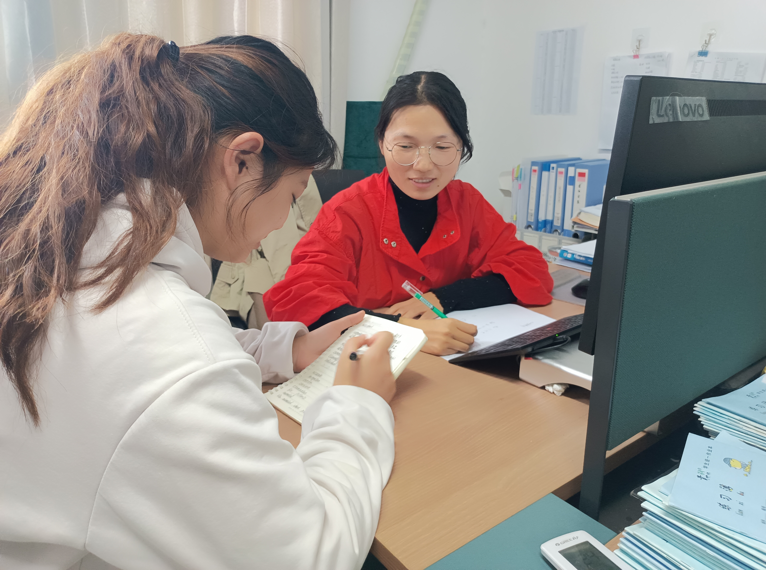

During the experiment, we still had questions about the drug treatment of malignant tumors. Therefore, we made an exclusive interview with Dr. Jufen Yan , an expert in microorganisms and drugs. " At present, there is no good treatment for malignant tumors, and some chemical drugs and radiotherapy have serious side effects, for which we need some new treatments. In particular, some targeted therapies to reduce the generation of drug side effects, "she said. After hearing our introduction to the project, she praised that our project is novel and can provide new ideas for the treatment of malignant tumors. At the same time, she also explained to us the drug R & D and clinical research in detail : A new drug can be submitted to the regulatory authorities for a new drug application only if it completes all three stages clinical trials and analyzes all the information and data, and the safety and efficacy of the drug is demonstrated. A new drug sometimes takes over a dozen years.

Dr. Jufen Yan 's words have given us great inspiration, the doctor affirmed our research direction. Next, our team will further optimize our project and begin to adjust the progress of the experiment in order to get a better treatment effect.

**8. Visit Ma'anshan Fengyuan Pharmaceutical Co. Ltd**

Our team visited the local pharmaceutical company in Ma'anshan. Considering that the drug has been developed, it needs mass production to be genuinely applied to medical treatment. Therefore, our team decided to visit the local pharmaceutical factory to investigate whether our manufacturing process could be applied to mass production. We chose to visit Ma'anshan Fengyuan Pharmaceutical Co., Ltd. because of its exquisite pharmaceutical technology and complete equipment.

In September, after repeated solicitation, we contacted the company and followed a member of the company to visit the pharmaceutical technology of the company under the condition of ensuring hygiene.

During the visit, the commentator explained the use of the company's pharmaceutical equipment to us in detail and put forward helpful suggestions for the manufacturing process of their laboratory. In order to apply）the drugs developed by the laboratory for large-scale production, our team improved our drug development process to better meet the needs of mechanized social production. To this end, I would like to thank Ma'anshan Fengyuan pharmaceutical company for providing us with this opportunity.

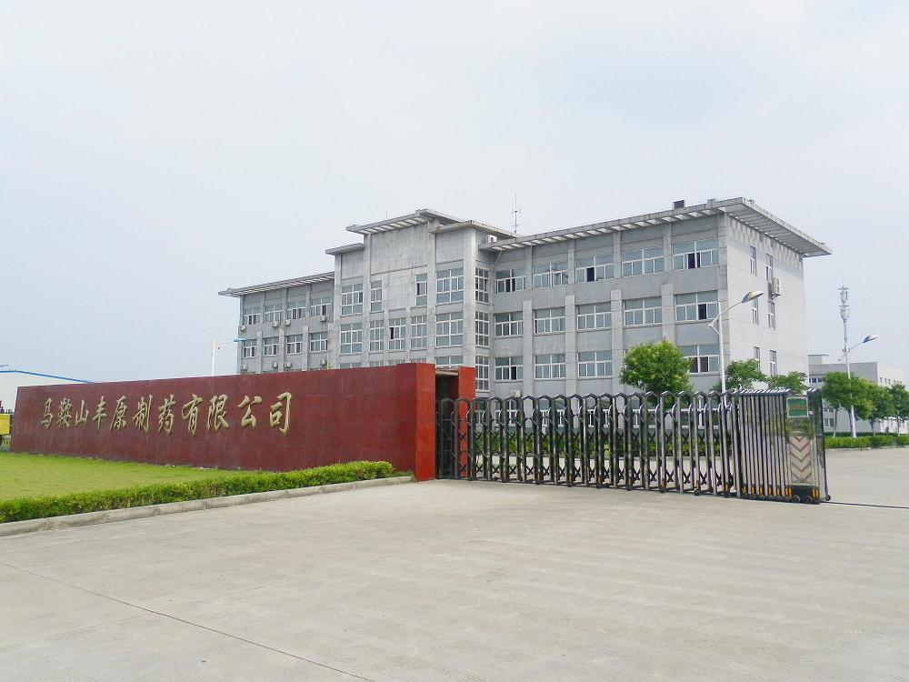

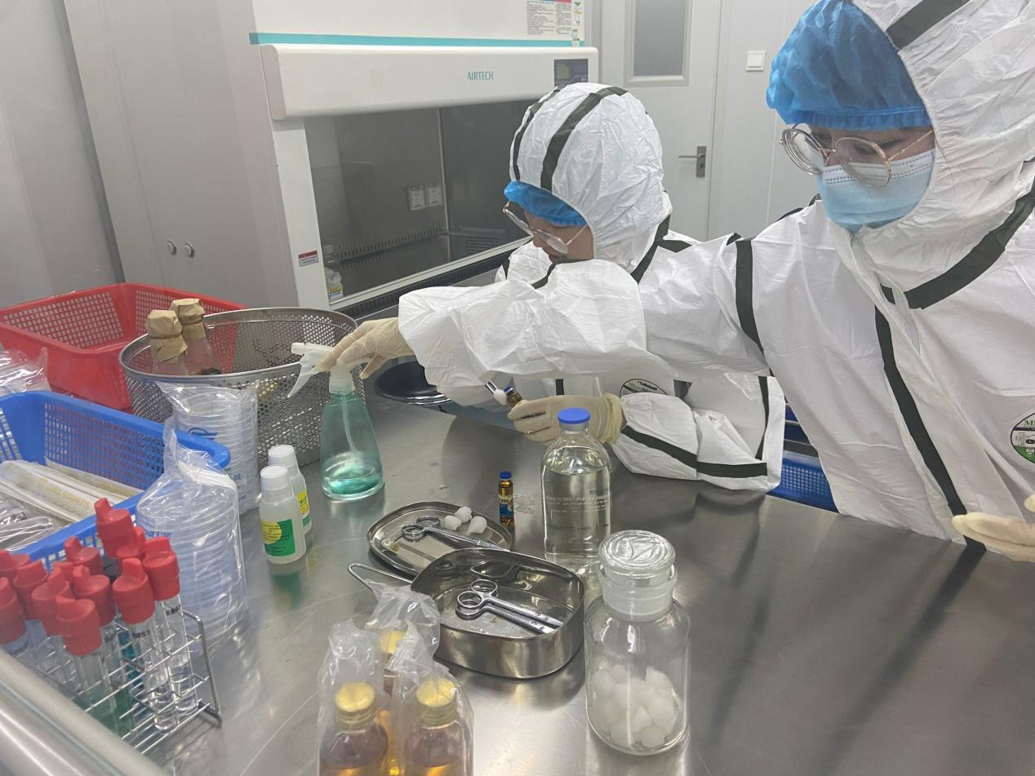

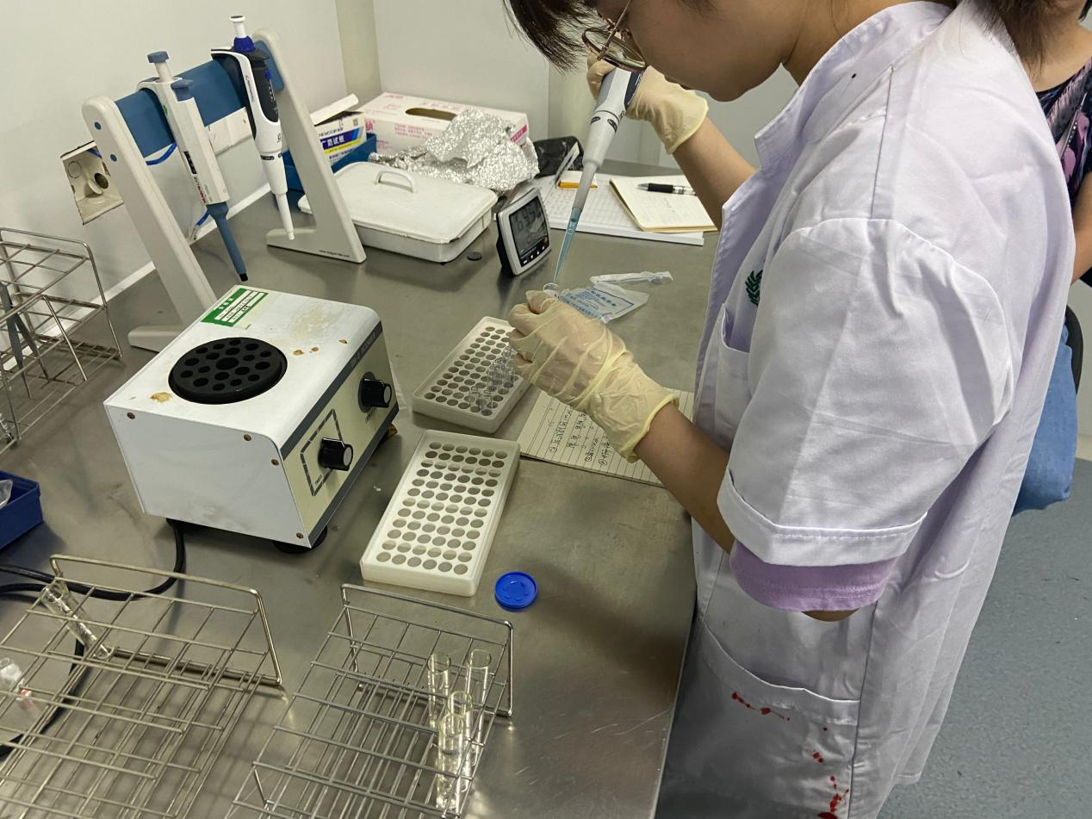

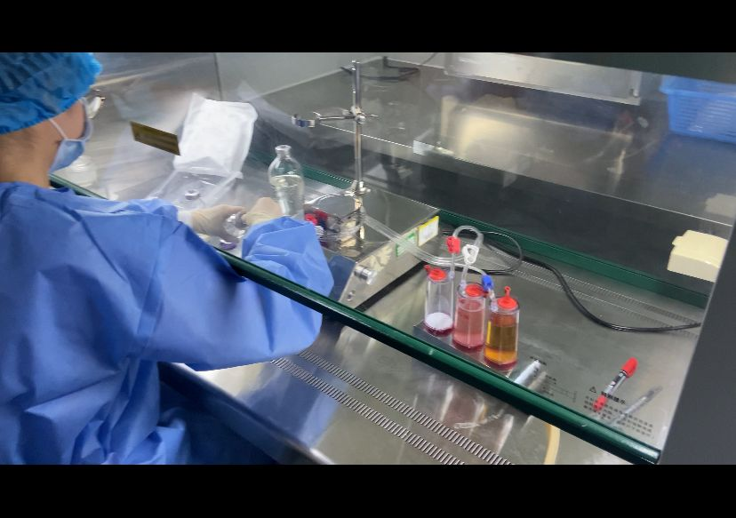

**9. Host the presentation**

In order to propagate the iGEM competition and our project , and make medical knowledge widely available, we invited representatives from each class to a presentation session held in the conference room.

In the meeting, our team presented the research project - novel targeted drugs against tumor cells, which has an excellent prospect for treating malignant tumors. At last, we explained the current common treatments for tumors and shared healthy diets. In daily life, students should live regularly, exercise moderately, and get enough sleep. More importantly, we should quit smoking and limit alcohol, avoid sugary drinks and limit the intake of high-quality and dense diets. The presentation allowed the students to understand more about tumors, not be afraid of them, and believe more in today's technology in scientific medical care.

After the meeting, many students asked some detailed questions about the characteristics of malignant tumors. We also had clear communication and discussion about the knowledge related to the novel targeted drugs developed by our team. Therefore, it proved to be a successful decision for us to hold the presentation. I believe that through our propaganda, everyone will be deeply impressed by the idea of engineered bacteria to treat breast cancer, targeted high-efficiency treatment, and targeted action on cancer cells. It is also the active discussion after the meeting that made us more aware of the victory Cancer cells are the current medical pain point. We will make unremitting efforts to this end. At the same time, we will do our utmost to promote the knowledge of cancer prevention.

